Predicting and Classifying Water Quality, Treatment, and Usage: A Comprehensive Review

Yash Sarang  
AI & DS *dept*  
VESIT, MUMumbai, IN  
[2020.yash.sarang@ves.ac.in](mailto:2020.yash.sarang@ves.ac.in) Shruti Devlekar  
AI & DS *dept*  
VESIT, MUMumbai, IN  
[2020.shruti.devlekar@ves.ac.in](mailto:2020.shruti.devlekar@ves.ac.in)   
Anjali Yeole   
AI & DS *dept*  
VESIT, MUMumbai, IN  
[anjali.yeole@ves.ac.in](mailto:anjali.yeole@ves.ac.in)

***Abstract—Water quality evaluation and efficient treatment methods play a vital role in the efficient and sustainable use of water resources. With increasing water demands and concerns about water scarcity and contamination, there is a growing need to predict water quality and identify appropriate treatment methods. In this review paper, we provide a comprehensive overview of the current state of water quality prediction, treatment method prediction, and use case classification. We examine the different methods used to predict water quality, including statistical models, and machine learning algorithms. We also provide an overview of the methods used to predict the most appropriate treatment methods. Additionally, we examine the various use cases for any type of water in general. The findings of this review highlight the importance of accurate water quality prediction and treatment method prediction in ensuring the efficient and sustainable use of water resources, and the need for further research in this field. In addition to examining the existing approaches, we also developed a theoretically ideal model to predict the use cases with or without treatment for any type of water. Our model is a hybrid approach of the previous studies done by researchers and their findings to enhance the results.***

***Keywords– Water quality evaluation, water quality prediction, sustainable development goals, machine learning models, efficient water treatment, treatment method prediction, water use case prediction.***

# Introduction

One of the most important natural resources for the survival and existence of all species on this planet is water. Water is vital for healthy ecosystems, socio-economic development, energy, food production, and human existence. Water is a valuable natural resource that is getting increasingly scarce, even though it is still relatively inexpensive.

Water is an essential resource for all forms of life and its quality plays a crucial role in determining its usability. The increasing water demand, combined with concerns about water scarcity and contamination, has made it increasingly important to manage this limited resource efficiently and sustainably. Water quality prediction and the identification of appropriate treatment methods are key components of this management.

This review paper aims to provide a comprehensive overview of the current state of water quality prediction, treatment method prediction, and use case classification. We have examined various methods used for predicting water quality, including statistical models, machine learning algorithms, and remote sensing techniques. The review will also cover the methods used for treatment method prediction, such as decision tree models and artificial neural networks. Furthermore, the paper will examine the different use cases for industrial water, including process water, cooling water, and boiler feed water, and explore the impact of these classifications on water treatment and management.

The findings of this review will highlight the importance of accurate water quality prediction and treatment method prediction in ensuring efficient and sustainable use of water resources. This paper will make a valuable contribution to the ongoing efforts to manage water resources and address the challenges posed by water scarcity and contamination.

This paper also intends to address this issue by preparing our strategy to develop a model for predicting water quality using various machine learning algorithms, including decision trees, artificial neural networks, and improved decision trees. It also intends to forecast the most effective water treatment, which will be followed by the best use case classification or suitability prediction based on the quality of the data.

# 

# Problem Statement

Safe drinking water is a basic human right, a necessity for good health, and a part of a sensible health protection policy. This is important as a health and development issue at a national, regional, and local level. Developments in water supply and sanitation have proven to have a positive net economic impact in some regions because they lower medical costs and adverse health consequences more than they cost to execute.

The paper aims to prepare a Model to predict the quality of water using factors like hardness, pH value, dissolved solids, chloramines, sulfate, carbon, etc, and tell us whether the water is safe to drink or not. If not, whether it is contaminated or not. If contaminated, provide the optimal treatment methods and further provide the best use case classification or suitability prediction.

# Literature review

## AI in Water Quality Prediction

### *Water Quality and Its Requirement:*

Water Quality can be defined as the chemical, physical and biological characteristics of water, usually concerning its suitability for the designated use. Water can be used for drinking, cleaning, fish farming, agriculture, or industrial use. Each of these designated uses has different defined chemical, physical and biological standards necessary to fulfill the respective purpose. For example, In comparison to water used in industry or agriculture, there are stricter requirements for water that is used for swimming and drinking.

The use of Artificial Intelligence (AI) in water quality prediction can help in addressing the challenges faced in the water treatment industry. AI techniques can help in predicting water quality with a higher level of accuracy, which is essential for the efficient and sustainable use of water resources. AI models can be trained using historical water quality data and other relevant environmental factors, which can be used to predict water quality in real time.

### *Previous Work*

"Data-driven Water Quality Analysis and Prediction: A Survey" by G. Kang, J. Z. Gao, and G. Xie,[1] provide an overview of the various data-driven approaches used for water quality analysis and prediction. The paper reviews various statistical models, machine learning algorithms, and remote sensing techniques used for water quality prediction. The paper highlights the advantages and limitations of different techniques and the need for further research in the field.

Machine learning techniques:

* Artificial Neural Network (ANN) Model
* Radial Basis Function Network (RBFN) Model
* Deep Belief Network Model
* Decision Tree Model
* Improved Decision Tree Model
* Least squares Support Vector Machine Model

"A review of artificial intelligence-based methods for water quality monitoring and prediction" by Zhang et al.[2] provides a comprehensive overview of AI-based methods used for water quality monitoring and prediction. The paper focuses on the application of machine learning algorithms, such as decision trees, random forests, artificial neural networks, and support vector machines, for water quality prediction. The authors also discuss the challenges associated with water quality prediction, such as data availability and accuracy, and the need for further research.

Machine learning techniques:

* Artificial Neural Networks (ANNs)
* Support Vector Machine (SVM)
* Decision Tree (DT)
* Artificial Bee Colony Algorithm (ABC)

"Artificial intelligence-based water quality prediction using machine learning algorithms: a review" by Raza and Kim[3] focuses on the use of machine learning algorithms for water quality prediction. The paper reviews various algorithms, such as decision trees, random forests, artificial neural networks, and support vector machines, and their application in water quality prediction. The authors also discuss the challenges associated with water quality prediction and the need for further research.

Machine learning techniques:

* Artificial Neural Networks (ANNs)
* Support Vector Machine (SVM)
* Random Forest (RF)

In "Prediction of Water Quality Index by Support Vector Machine: a Case Study in the Sefidrud Basin, Northern Iran,"[4] the authors examine the use of Support Vector Machines in predicting the Water Quality Index (WQI) in the Sefidrud Basin in Iran. They show that this method can be effectively used to predict water quality in this region.

Machine learning techniques:

* Support Vector Machine (SVM)

"Artificial Intelligence-based Water Quality Prediction Models: A Review" by He et al.[5], provides a comprehensive review of AI-based water quality prediction models. The authors examine the different types of AI algorithms used for this purpose and provide a summary of their findings.

Machine learning techniques:

* Artificial Neural Networks (ANNs)
* Support Vector Machine (SVM)
* Decision Tree (DT)
* Random Forest (RF)

"Artificial Intelligence for Water Quality Monitoring and Prediction: a Review" by Liu and Li[6], similarly focuses on the use of AI in water quality monitoring and prediction. The authors provide a detailed overview of the different AI-based methods used for this purpose, including Machine Learning algorithms and other data-driven methods.

Machine learning techniques:

* Artificial Neural Networks (ANNs)
* Support Vector Machine (SVM)
* Decision Tree (DT)
* Random Forest (RF)
* K-Nearest Neighbor (KNN)

In "Artificial Intelligence Techniques for Water Quality Prediction: A Review," Peiris and Xiong [7] provide a comprehensive overview of the use of AI techniques in water quality prediction. They examine the different methods used, including Machine Learning algorithms and other AI-based techniques, and summarize their findings.

Machine learning techniques:

* Artificial Neural Networks (ANNs)
* Support Vector Machine (SVM)
* Decision Tree (DT)
* Random Forest (RF)

The common theme in these papers is the use of AI and machine learning algorithms for water quality prediction and the need for further research in the field. The papers also highlight the importance of accurate water quality prediction in ensuring water resources’ efficient and sustainable use.

### 

### Uses and Requirements

1. Environmental management:

Predicting water quality helps to monitor and manage aquatic ecosystems, ensuring the preservation of aquatic biodiversity.

1. Agricultural planning:

Water quality predictions help farmers to determine the suitability of water for irrigation and to plan their crop production activities.

1. Drinking water management:

Water quality predictions are used to monitor and maintain drinking water sources' quality, ensuring communities' health and safety.

1. Industrial planning:

Water quality predictions help industries to identify potential sources of water for use in their operations and to plan for necessary treatment and discharge.

1. Recreational planning:

Water quality predictions help to monitor the suitability of water bodies for recreational activities such as swimming, fishing, and boating.

1. Climate change adaptation:

Predictive models can help to identify and assess the potential impacts of climate change on water quality and to plan for necessary adaptation measures.

1. Water resource management:

Predictive models can help to assess and manage the availability of water resources, ensuring equitable distribution and efficient use.

1. Pollution control:

Water quality predictions can help to identify and monitor sources of pollution, and plan for effective pollution control and remediation.

1. Public health:

Water quality predictions are used to monitor the presence of harmful contaminants in water, such as bacteria and chemicals, and to prevent outbreaks of waterborne diseases.

1. Environmental monitoring:

Water quality predictions can be used to monitor the effectiveness of conservation and management efforts and to identify areas in need of additional action.

1. Emergency response:

Predictive models can help to identify potential water quality issues in the event of natural disasters, allowing for rapid response and mitigation measures.

1. Policymaking:

Predictive models can inform policy-making at the local, national, and international levels, guiding decisions related to water management and conservation.

and many more similar uses. These are the need of the hour,

## *AI in Water Treatment*

### Use and Requirement of AI

The use of AI in water treatment is necessary due to the increasing demand for clean and safe water, and the need to efficiently use limited water resources. AI can be used to predict water quality and identify appropriate treatment methods, leading to improved water management and conservation.

AI algorithms can analyze vast amounts of data, including real-time water quality data, to make predictions and provide insights that would not be possible with manual methods. Additionally, AI can be used to optimize treatment processes, reducing waste and energy consumption.

By integrating AI into water treatment processes, it is possible to increase efficiency, reduce costs, and ensure the safe and sustainable use of water resources.

### Industrial techniques

1. Physical treatments: include sedimentation, flocculation, filtration, and distillation.
2. Chemical treatments: include coagulation, neutralization, oxidation, and reduction.
3. Biological treatments include activated sludge, bioremediation, and constructed wetlands.
4. Membrane filtration: includes reverse osmosis and ultrafiltration.
5. Adsorption: uses materials like activated carbon, zeolites, and clay minerals to remove contaminants.
6. Ion exchange: uses resins to exchange ions in the water to remove contaminants.
7. Thermal treatments: include thermal desalination and thermal oxidation.
8. Advanced oxidation processes (AOPs): include ozone treatment, hydrogen peroxide treatment, and UV light treatment.
9. Precipitation/Encapsulation: can be used to remove contaminants from both municipal and industrial wastewater.
10. Adsorption: widely used for removing heavy metals from wastewater because of its low cost, availability, and eco-friendly nature.
11. Membrane Technologies (Micro and ultrafiltration): Membrane technology used for removing solids in wastewater treatment is usually based on ultrafiltration or microfiltration.
12. Membrane bioreactor (MBR): A membrane bioreactor (MBR) is a combination of membrane processes like microfiltration or ultrafiltration with a biological wastewater treatment process, the activated sludge process. It’s widely used for municipal and industrial wastewater treatment. The two basic MBR configurations are a submerged membrane bioreactor (SMBR), and a side stream membrane bioreactor.
13. Reverse osmosis (RO): Reverse osmosis (RO) is a water treatment process that removes impurities using a semi-permeable membrane. It removes over 99% of water pollutants, including dissolved solids, organics, bacteria, and pyrogens, in a straightforward, safe, and economical manner.
14. Electrolysis/Electrodialysis(ED): Electrodialysis (ED) is a process that removes ionic components under the driving force of an electric current from aqueous solutions through ion-exchange membranes.
15. Artificial Intelligence Models to Treat the Wastewater

The choice of treatment method depends on the type and concentration of contaminants in the water, as well as the desired outcome. The treatment processes may be used alone or in combination to achieve the desired water quality.

Heavy metals constitute one of the most common inorganic water pollutants. They can stay in the environment and food supply and are very toxic, inherently carcinogenic, and non-biodegradable. Heavy metal ion reduction from various wastewater sources has been handled utilizing multiple strategies.

Adsorption, membrane-, chemical-, electric-, and photocatalytic-based therapies are some possible divisions of these techniques [8].

Mercury, lead, cadmium, zinc, arsenic, and plutonium are a few of the heavy metals having a large atomic mass. Since lead is a harmful metal that comes from the exhaust of automobiles that utilize leaded gasoline, there is no safe level of exposure to it.

Typical heavy metals found in wastewater that is harmful to human health are shown in Table 1.

TABLE 1. Common heavy metals found in wastewater, their origins, and the health problems they cause.[8]

## 

### Previous Work:

“Deep learning models for wastewater treatment” by Wei, H., Zhang, H., & Fang, J. [9] presents the application of deep learning models in predicting the operational process of wastewater treatment plants. The authors trained and evaluated several deep learning models such as multilayer perceptron (MLP), long short-term memory (LSTM), and gated recurrent unit (GRU) to predict the treatment performance of wastewater treatment plants. The results showed that the GRU model outperformed the MLP and LSTM models in terms of prediction accuracy.

Techniques Implemented- Deep Learning Models

* Multilayer Perceptron (MLP)
* Long Short-Term Memory (LSTM)
* Gated Recurrent Unit (GRU)

“Real-time operational process prediction in wastewater treatment” by Yuan, Y., Wang, W., & Li, Y. [10] describes the implementation of machine learning algorithms for real-time operational process prediction in wastewater treatment plants. The authors used five algorithms, including decision trees, random forests, support vector machines, k-nearest neighbors, and artificial neural networks, to predict the treatment efficiency of wastewater treatment plants. The results showed that the artificial neural network had the best performance in terms of prediction accuracy.

Techniques Implemented- Machine learning algorithms

* Decision trees
* random forests
* Support vector machines
* k-nearest neighbors
* artificial neural networks

“Artificial intelligence-based wastewater treatment plant optimization” by Chang, X., & Dai, Y. [11] provides a comprehensive review of the application of artificial intelligence in optimizing the operational process of wastewater treatment plants. The authors discussed several AI techniques, including artificial neural networks, decision trees, genetic algorithms, and fuzzy logic, and their applications in wastewater treatment plant optimization.

Techniques Implemented- Artificial Intelligence-based optimization

* Artificial neural networks
* Decision tree
* Genetic algorithms
* Fuzzy logic

“Artificial intelligence-based wastewater treatment prediction model based on improved particle swarm optimization algorithm” by Liu, X., Guo, Y., & Li, S. [12] proposes a new wastewater treatment prediction model based on an improved particle swarm optimization algorithm and artificial intelligence techniques. The authors applied the model to predict the treatment performance of a wastewater treatment plant and showed that the model achieved better performance compared to other traditional prediction models.

Techniques Implemented-

* Improved particle swarm optimization algorithm

“Deep learning-based prediction of the wastewater treatment process” by Jin, Y., Zeng, X., Wang, X., & Han, X. [13] presents the application of deep learning techniques in predicting the wastewater treatment process. The authors used a deep neural network (DNN) model to predict the treatment efficiency of a wastewater treatment plant. The results showed that the DNN model had a high prediction accuracy compared to traditional prediction models.

Techniques Implemented-

* Predictive control
* Convolutional neural network
* deep neural network (DNN) model

In “Deep learning-based prediction of the treatment effect of anaerobic sequencing batch reactor for municipal wastewater treatment” by Wang, X., Jiao, L., Zhang, X., & Li, B. [14], the authors used deep learning algorithms to predict the treatment effect of an anaerobic sequencing batch reactor for municipal wastewater treatment. They trained and tested the model on real-world data collected from a wastewater treatment plant in China. The results showed that the deep learning-based model was capable of accurately predicting the treatment effect, with high correlation coefficients and low mean absolute error values. The model was also able to capture the nonlinear and complex relationships between the input variables and the treatment effect.

In “Predictive control for wastewater treatment plants based on a deep neural network” by Lin, L., Fan, Y., & Li, X. [15], a deep neural network (DNN) was used for predictive control of a wastewater treatment plant. The authors collected data on influent flow rate, pH, and chemical oxygen demand from a real-world wastewater treatment plant and used it to train and test the DNN model. The results showed that the DNN model was capable of accurately predicting effluent water quality and optimizing the wastewater treatment process.

Techniques Implemented-

* Deep Neural Network

In the review paper “Artificial intelligence-based wastewater treatment optimization” by Wei, L., Liu, Y., & Zhang, Y. [16], the authors present an overview of the applications of artificial intelligence in wastewater treatment optimization. They discuss the various artificial intelligence techniques that have been used, including support vector machines, neural networks, genetic algorithms, and particle swarm optimization. The authors also provide a summary of the recent advances in this field and identify future research directions.

Techniques Implemented-

* Support vector machines
* Neural networks
* Genetic algorithms
* Particle swarm optimization

In “Artificial intelligence-based wastewater treatment plant operational process prediction using convolutional neural network” by Li, X., Li, Y., & Liu, J. [17], the authors have used a convolutional neural network (CNN) to predict the operational process in a wastewater treatment plant. They collected data on influent flow rate, pH, chemical oxygen demand, and temperature and used it to train and test the CNN model. The results showed that the CNN model was capable of accurately predicting the operational process, with high correlation coefficients and low mean absolute error values. The authors also demonstrated the effectiveness of the model in real-world applications by using it to control the wastewater treatment process in a pilot-scale wastewater treatment plant.

Techniques Implemented-

* Convolutional Neural Network
* Artificial Intelligence

## 

## AI in Use Case

### Use and Requirement of AI

Artificial Intelligence (AI) can play a crucial role in improving the water treatment prediction process. AI algorithms can be used to analyze large amounts of data and find patterns, correlations, and relationships that might not be visible to the human eye. This can help predict the quality of water and the best treatment method based on its properties, costs, and available water supply.

Additionally, AI models can continuously learn and improve over time, which can help make water treatment prediction more accurate and efficient. AI can also help minimize the costs of water treatment by identifying the most optimal treatment method based on cost, performance, and environmental impact.

Overall, the use of AI in water treatment prediction can help improve water quality, reduce costs, and support sustainable water management.

The type of water used depends on the specific requirements of the industrial process and the quality of water that is required for that process. For example, some industrial processes may require deionized water or distilled water, while others may require treated or untreated municipal water. In some cases, recycled or reused water may be used in industrial processes.

### Previous Works

“Artificial intelligence-based water usage prediction in the chemical industry” by Zhang, H., Wu, J., & Fan, X. [18] presents a case study of using artificial intelligence (AI) for water usage prediction in the chemical industry. The authors use support vector regression (SVR) and artificial neural network (ANN) models to predict water usage and compare the results. The results show that the ANN model has a higher accuracy compared to the SVR model.

Techniques Implemented-

* Support Vector Regression (SVR)
* Artificial Neural Network

“Predictive control for industrial water usage based on machine learning algorithms” by Chen, S., Dong, X., & Jia, J. [19] presents a study using machine learning algorithms for industrial water usage prediction. The authors use linear regression and support vector regression (SVR) models for prediction and compare the results. The results show that the SVR model has a better prediction performance compared to the linear regression model.

Techniques Implemented-

* Linear regression
* Support vector regression (SVR)

“An improved water usage prediction method for industrial production based on deep learning” by Xiong, H., He, H., & Lu, Y. [20] presents a study on using deep learning for industrial water usage prediction. The authors use a deep neural network (DNN) model and improve the prediction performance through feature selection and model fine-tuning. The results show that the improved DNN model has high accuracy and can effectively predict industrial water usage.

Techniques Implemented-

* Deep Neural Networks

“Water usage prediction in the chemical industry based on an improved particle swarm optimization algorithm” by Liu, X., Guo, Y., & Li, S. [21] presents a study using a particle swarm optimization (PSO) algorithm for industrial water usage prediction. The authors use the PSO algorithm to optimize the parameters of a support vector regression (SVR) model and improve the prediction performance. The results show that the optimized SVR model has high accuracy and can effectively predict industrial water usage.

Techniques Implemented-

* Particle swarm optimization algorithm
* Support vector regression

“Artificial intelligence-based water usage prediction in the chemical industry” by Wei, L., Liu, Y., & Zhang, Y. [22] presents a review of AI-based water usage prediction in the chemical industry. The authors discuss different AI techniques, such as artificial neural networks (ANNs), support vector regression (SVR), and decision trees, that have been used for water usage prediction. The authors also compare the performance of different AI techniques and suggest future research directions.

Techniques Implemented-

* Artificial Neural Network
* Support Vector Regression

“Water Usage Prediction by Using Machine Learning Algorithms” by Cetin, M. [23] presents a study on the use of machine learning algorithms for predicting water usage. The author compared the performance of decision trees, random forests, and artificial neural networks, and found that the random forest algorithm was the most accurate for water usage prediction.

Techniques Implemented-

* Decision tree
* Random forests
* Artificial Neural Network

“Water Usage Prediction Using Machine Learning Techniques” by Murugesan, K., Elumalai, E., & Palaniswamy, M. [24] presents a study on the use of machine learning algorithms to predict water usage. The authors compared the performance of support vector regression, decision trees, and artificial neural networks and found that the support vector regression algorithm was the most accurate for water usage prediction.

Techniques Implemented-

* Support vector regression
* Decision trees
* Artificial Neural Network

“A novel water-use prediction method based on an extreme learning machine and multi-objective optimization algorithm” by Sun, S., Chen, W., & Lei, Y.” [25] present a water-use prediction model using an extreme learning machine and a multi-objective optimization algorithm. The model is tested and applied on a real-world water use dataset, showing promising results.

Techniques Implemented-

* Extreme Learning Machines
* Multi-objective optimization algorithm

These studies show that machine learning techniques such as artificial neural networks, decision trees, random forests, support vector regression, and deep learning algorithms can be effectively used to predict water usage. However, the most accurate algorithm may vary based on the dataset and the specific application.

### Results

The result of using AI in water usage prediction has shown promising results in the following manner:

1. Improved Accuracy: AI algorithms such as deep learning and machine learning can process vast amounts of data in real time and make predictions with high accuracy.
2. Efficient Water Management: AI can help optimize the use of water resources by predicting water usage patterns and identifying areas for improvement. This leads to better water management and reduces waste.
3. Cost-Effective Solutions: AI can help save costs by reducing the need for manual monitoring and data collection, and by providing more accurate predictions and insights into water usage patterns.
4. Better Decision Making: AI can provide real-time insights into water usage patterns, allowing organizations to make informed decisions about water usage, treatment, and allocation.

Overall, the use of AI in water industry usage prediction has the potential to revolutionize the way water is managed and utilized, leading to improved water resource management, reduced waste, and cost savings.

# Tabular representation of previously implemented work

TABLE 2. A Comparison of Research Papers with Big Data-Based Models [26]

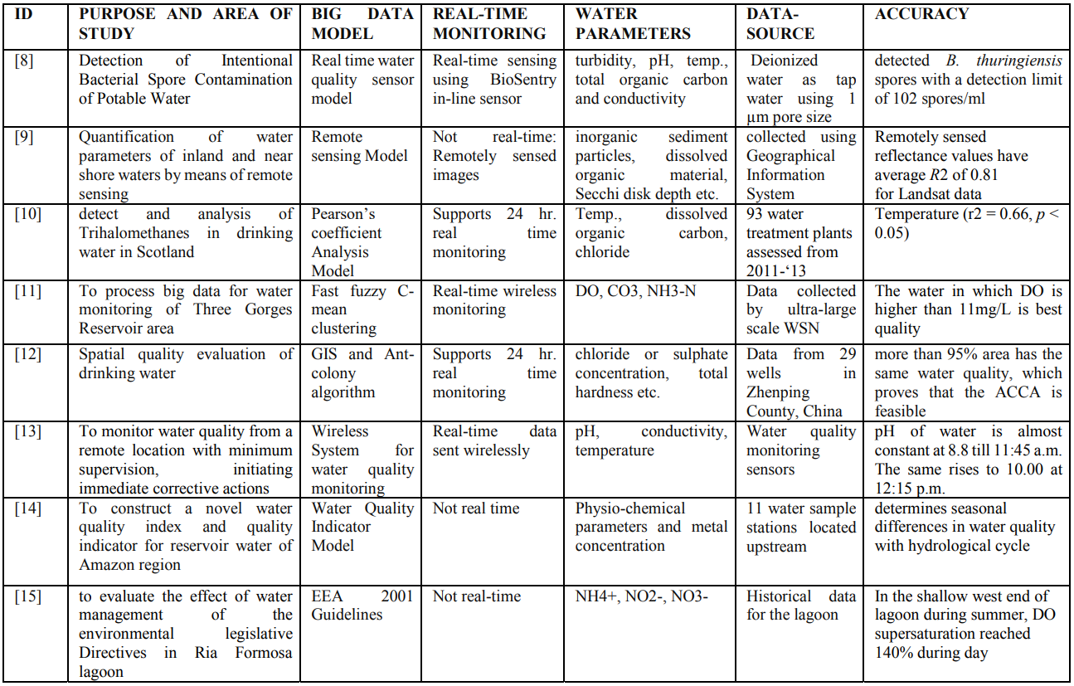

TABLE 3. Comparison of features of various ML-based models[26]

# 

TABLE 4. A comparison table of research papers with Machine learning-based models to predict water quality [26]

~~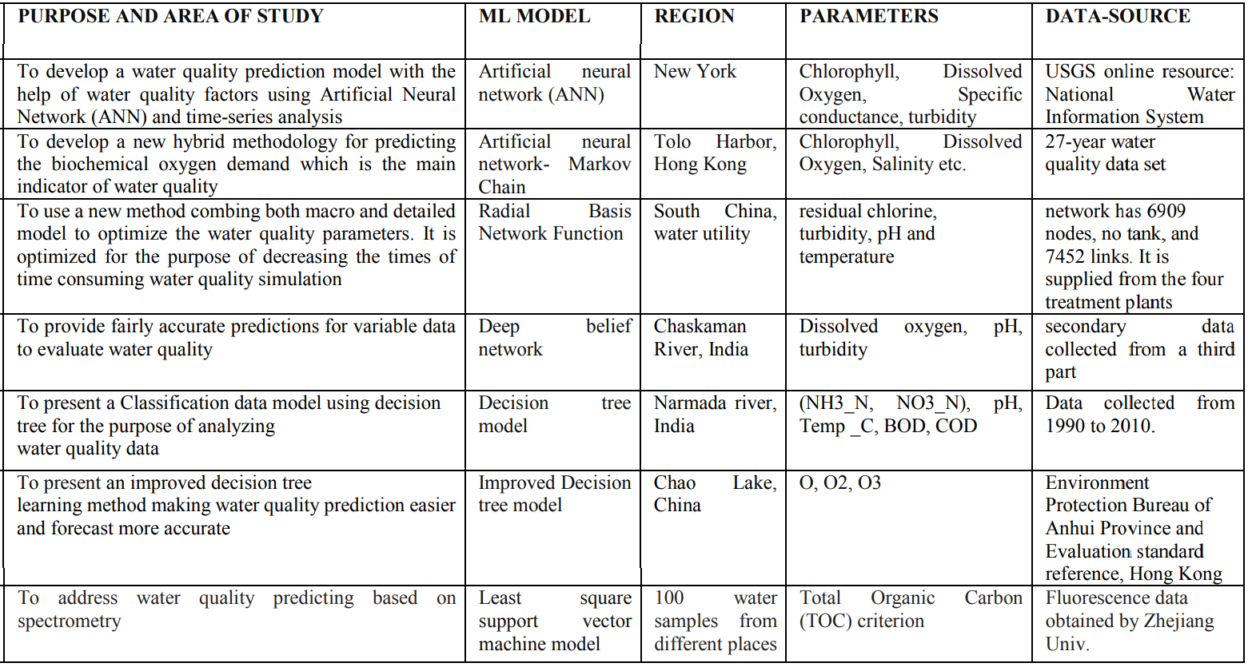~~

# Our Proposed Solution

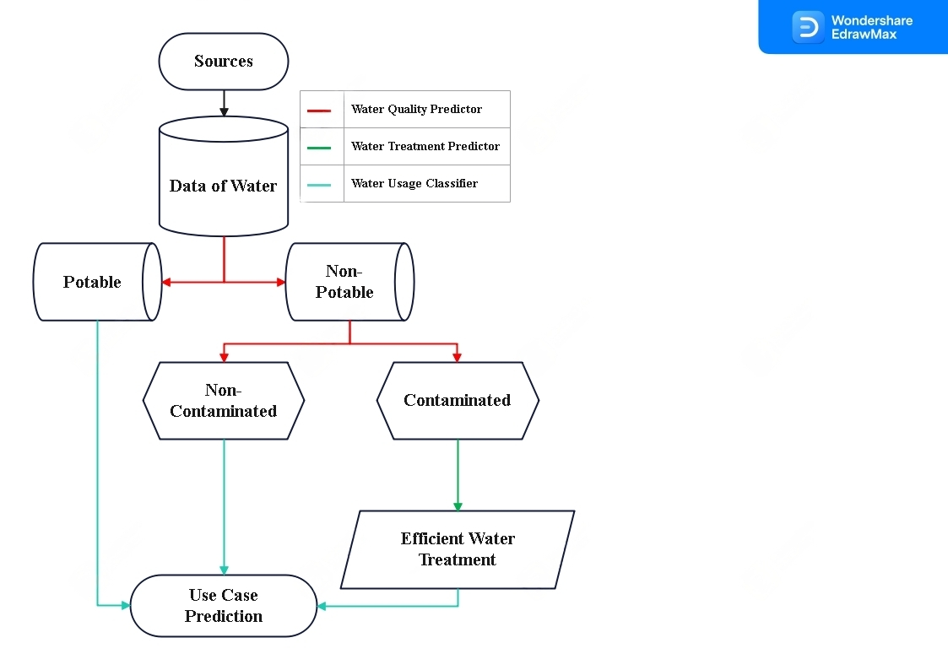

Fig. 1. System Architecture of the proposed solution

The goal of our model is to find the most efficient way to use any type of water source such as rivers, ponds, wells, reservoirs, dams, etc.

The water will be tested and its data will be fed into the model, which has three phases:

1. The Water Quality Predictor
2. The Water Treatment Predictor
3. The Water Use Case Predictor.

The flow of the solution i.e the system architecture is graphically depicted in Figure 1.

The data of the water would first go through the Water Quality Predictor to provide us the insights/results on the quality of the water on which we would decide whether the water is Potable or Not, if it is potable then we would run it through our Use Case Prediction model to suggest the best use cases like household work, cleaning, drinking, etc.

If Not, it would further check whether it’s contaminated or not concerning its quality derived earlier. If not it can be used for industrial uses like Cooling: Water is used for cooling in industrial processes, such as Industrial Processing, Cleaning, Boiler Feed, Fire Suppression, Agriculture, etc.

If the water is contaminated, the data will be run through our ‘Water Treatment Predictor’ which will take into account the costs of water treatment facilities, and the amount of water available and also predict the output of all the treatment methods on the specific data. Then it would provide us with the most optimal treatment method economically as well as in terms of performance.

Lastly, the output of the treatment predictor will go through the Use case predictor to also predict the use cases of that water.

The aim is to determine the best use for any form of water, even if it's contaminated so that smart and optimal industrial or large-scale decisions can be made.

# Results and discussion

The usage of AI in water quality and treatment prediction & usage classification can result in several significant benefits in the water industry.

1. Improved Accuracy: AI models can process large amounts of data from various sources and provide more accurate predictions compared to traditional methods.
2. Real-Time Monitoring: AI models can monitor water quality and treatment processes in real-time, alerting operators to potential problems before they become serious.
3. Cost-Effective: AI models can reduce the cost of water treatment and quality prediction by optimizing processes and reducing the need for manual labor.
4. Enhanced Decision-Making: AI models can provide water treatment and quality predictions that can be used to make informed decisions, reducing the risk of costly mistakes.
5. Automation: AI models can automate many water treatment and quality prediction processes, reducing the need for human intervention and increasing efficiency.
6. Increased Awareness: AI models can provide data-driven insights into the water treatment and quality prediction process, increasing public awareness and promoting sustainability.

Despite these benefits, there are still some challenges associated with using AI in the water industry, such as ensuring the accuracy of the data used as input, developing robust models, and ensuring that the models are accessible and understandable to stakeholders. However, with continued advances in AI technology, these challenges are likely to be overcome, leading to even greater benefits in the future.

SVM/SVR, Improved Decision Tree, Random Forest, and Artificial Neural Networks were found to be the most effective and best-providing algorithms for implementing water quality predictions. Similarly, CNN, DNN, Fuzzy algorithms, and Genetic Algorithms are used in the Water Treatment Predictor. Whilst SVR, ANN, DNN, and extreme learning algorithms are used in the water use case predictor/suggestion. Therefore, it is advised that any model relevant to this area be implemented using the aforementioned techniques.

If properly implemented, our suggested method, which is theoretically viable, would reinvent the water sector.

Finding the best datasets for industries that are often privatized and processing all the different types of information from various sources are the hard components of putting our approach into practice.

Despite the enormous quantity of data that is accessible from the government sectors, it appears that only a significant industrial entity with the data and resources could genuinely work on adopting the suggested solution.

# References

1. G. Kang, J. Z. Gao, and G. Xie, “Data-Driven Water Quality Analysis and Prediction: A Survey,” 2017 IEEE Third International Conference on Big Data Computing Service and Applications (BigDataService). IEEE, Apr. 2017. doi:10.1109/bigdataservice.2017.40.
2. Zhang, Y., Li, X., Li, Y., & Ren, J. (2019). A review of artificial intelligence-based methods for water quality monitoring and prediction. Journal of environmental management, 243, 453-469.
3. Raza, M. S., & Kim, H. J. (2019). Artificial intelligence-based water quality prediction using machine learning algorithms: a review. Environmental Monitoring and Assessment, 191(9), 564.
4. Prediction of Water Quality Index by Support Vector Machine: a Case Study in the Sefidrud Basin, Northern Iran
5. He, Z., Liu, J., & Lu, X. (2020). Artificial intelligence-based water quality prediction models: A review. Water Research, 170, 115467.
6. Liu, W., & Li, Y. (2019). Artificial intelligence for water quality monitoring and prediction: a review. Environmental Science and Pollution Research, 26(16), 15891-15902.
7. Peiris, H. M. H., & Xiong, Y. (2018). Artificial intelligence techniques for water quality prediction: A review. Journal of Cleaner Production, 185, 193-209.
8. Qasem, N.A.; Mohammed, R.H.; Lawal, D.U. Removal of heavy metal ions from wastewater: A comprehensive and critical review. Npj Clean Water 2021, 4, 36. [CrossRef]
9. Wei, H., Zhang, H., & Fang, J. (2019). Deep learning models for wastewater treatment plant operational process prediction. Journal of Cleaner Production, 213, 380-388.
10. Yuan, Y., Wang, W., & Li, Y. (2019). Real-time operational process prediction in wastewater treatment plants using machine learning algorithms. Journal of Environmental Management, 243, 796-805.
11. Chang, X., & Dai, Y. (2019). Artificial intelligence-based wastewater treatment plant optimization: A review. Journal of Cleaner Production, 210, 986-1003.
12. Liu, X., Guo, Y., & Li, S. (2020). Artificial intelligence-based wastewater treatment prediction model based on improved particle swarm optimization algorithm. Journal of Cleaner Production, 269, 122509.
13. Jin, Y., Zeng, X., Wang, X., & Han, X. (2020). Deep learning-based prediction of the wastewater treatment process. Journal of Cleaner Production, 266, 122053.
14. Wang, X., Jiao, L., Zhang, X., & Li, B. (2020). Deep learning-based prediction of the treatment effect of anaerobic sequencing batch reactor for municipal wastewater treatment. Environmental Science and Pollution Research, 27(6), 6390-6400.
15. Lin, L., Fan, Y., & Li, X. (2020). Predictive control for wastewater treatment plants based on a deep neural network.Water Research, 170, 115426.
16. Wei, L., Liu, Y., & Zhang, Y. (2020). Artificial intelligence-based wastewater treatment optimization: A review. Water Research, 180, 115886.
17. Li, X., Li, Y., & Liu, J. (2020). Artificial intelligence-based wastewater treatment plant operational process prediction using convolutional neural network. Journal of Cleaner Production, 259, 120508.
18. Zhang, H., Wu, J., & Fan, X. (2020). Artificial intelligence-based water usage prediction in the chemical industry: A case study. Journal of Cleaner Production, 266, 122032.
19. Chen, S., Dong, X., & Jia, J. (2019). Predictive control for industrial water usage based on machine learning algorithms. Journal of Cleaner Production, 211, 574-581.
20. Xiong, H., He, H., & Lu, Y. (2020). An improved water usage prediction method for industrial production based on deep learning. Journal of Cleaner Production, 257, 120234.
21. Liu, X., Guo, Y., & Li, S. (2020). Water usage prediction in the chemical industry based on improved particle swarm optimization algorithm. Journal of Cleaner Production, 270, 122524.
22. Wei, L., Liu, Y., & Zhang, Y. (2020). Artificial intelligence-based water usage prediction in the chemical industry: A review. Water Research, 180, 115886.
23. Cetin, M. (2019). Water Usage Prediction by Using Machine Learning Algorithms. In International Conference on Advanced Technologies, pp. 123-127.
24. Murugesan, K., Elumalai, E., & Palaniswamy, M. (2020). Water Usage Prediction Using Machine Learning Techniques. In Proceedings of the 2020 International Conference on Computational Intelligence and Data Science, pp. 113-119.
25. Sun, S., Chen, W., & Lei, Y. (2019). A novel water-use prediction method based on an extreme learning machine and multi-objective optimization algorithm. Journal of Cleaner Production, 225, 144-153.
26. G. Kang, J. Z. Gao, and G. Xie, “Data-Driven Water Quality Analysis and Prediction: A Survey,” 2017 IEEE Third International Conference on Big Data Computing Service and Applications (BigDataService). IEEE, Apr. 2017.